Ylopo Adaptive Search
Objectives for today:
∙ Learn how to use social media to grow and market your business with free tools provided by Scofield.
∙ Learn the basics of paid advertising. ∙ Social media strategy: what, when, and how often. Resources.
1. Promote your BRAND – DO THIS ONCE A day
Use Facebook & your Website to get FREE / PAID FOR – Retargeting

∙ What is retargeting? (think of it as being tagged)
∙ Utilize your branded search site to create searches, just sold, just listed & open houses posts to drive traffic to your page
∙ Post this on yourpage, in groups, and the FB marketplace ∙ Anyone who clicks on it gets retargeted for YOU …. once they fill in the info, it sends it back to you in FUB
Quick Facebook Post Example & Live Demonstration:
First, go to your search site: this shows company as find.scofieldgorup.com, yours is assigned usually name.scofieldgroup.com like your email.
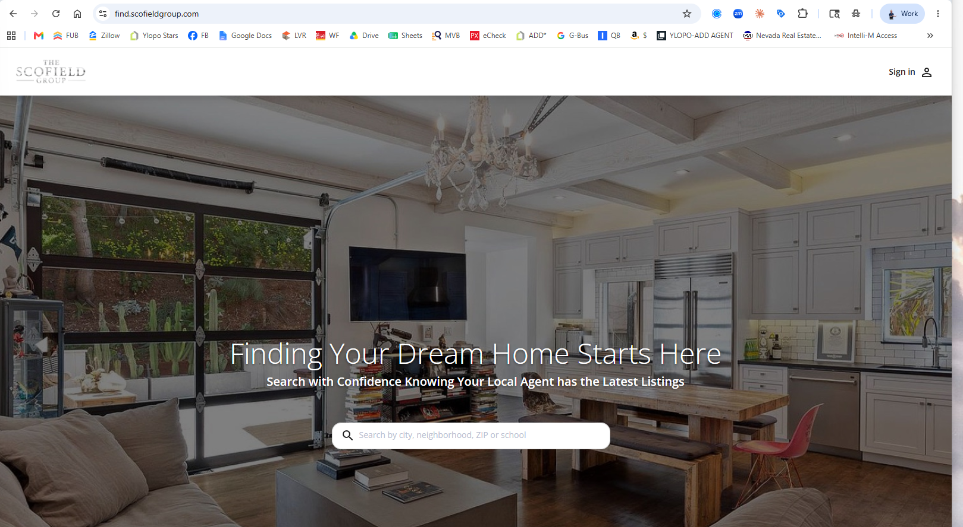
Type in Las Vegas, choose Las Vegas
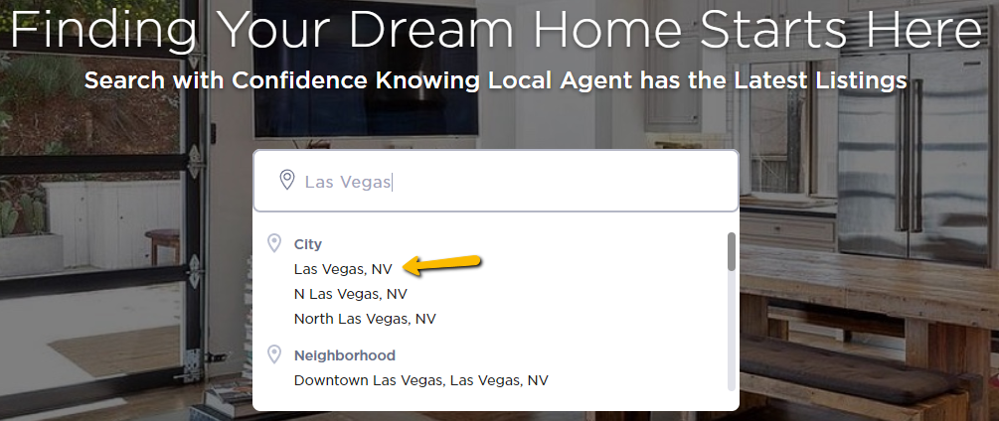
Click on More Filters

For an Active Listing, please find one of our Active listings from the MLS (Never a listing from another brokerage)
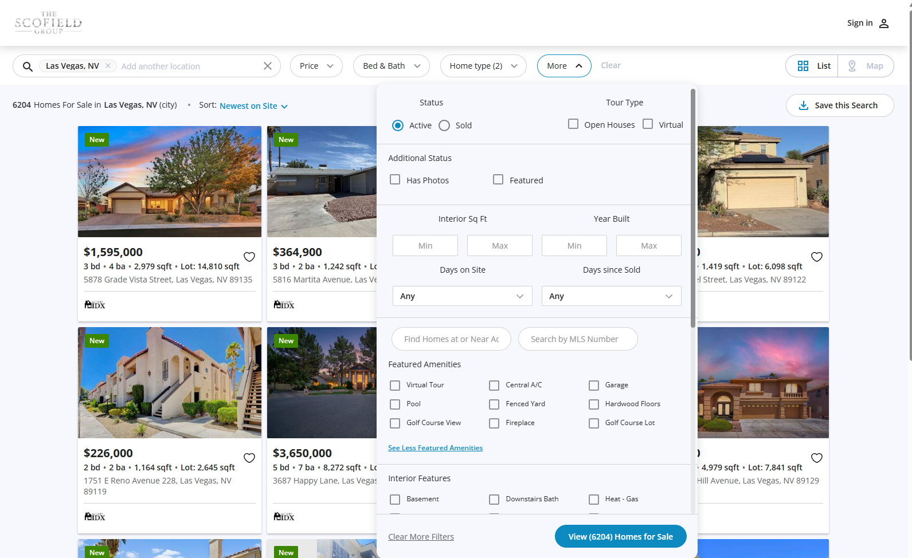

Click on View (xxx) Homes for Sale
Then Copy the URL
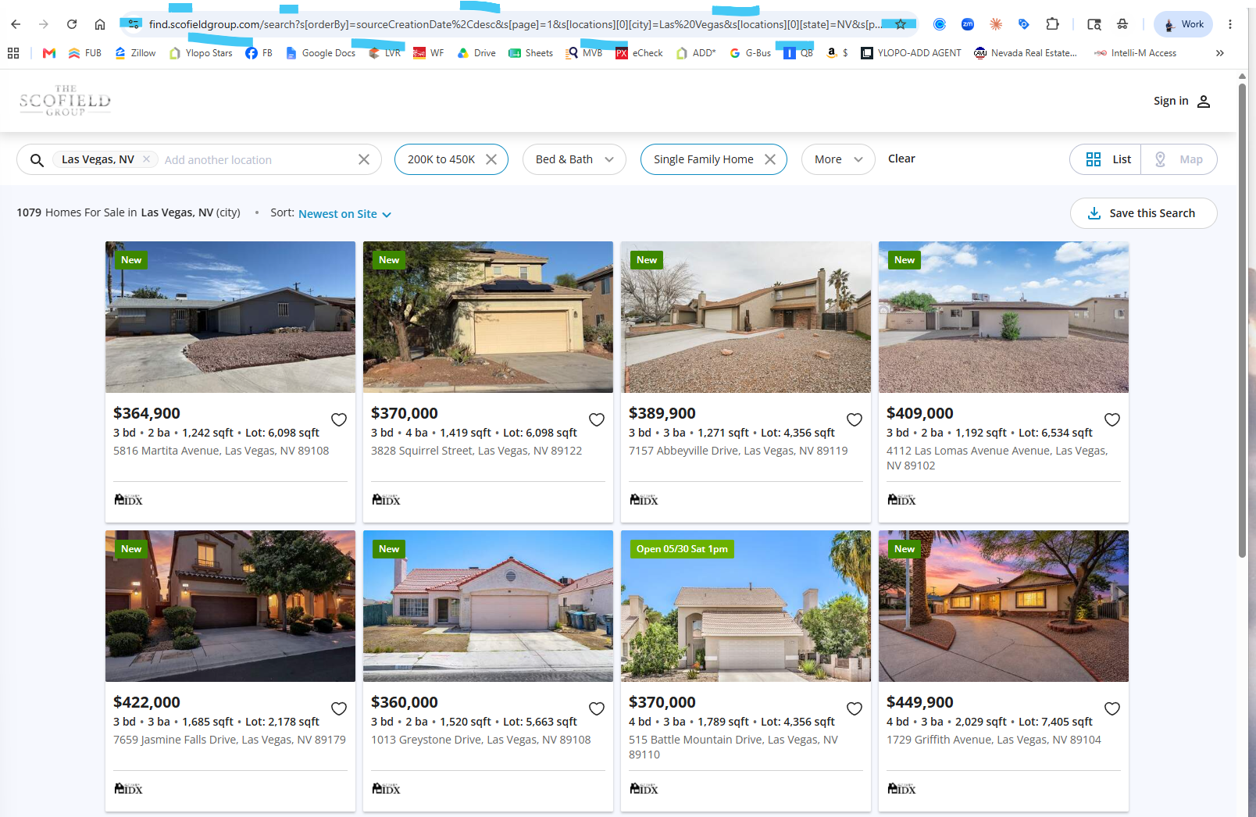

Paste into a Facebook Post and remove all characters following the first set of numbers.
Use Emojis and backlinks in Comments; the long copy is fine, but BREAK IT UP and space out sections using punctuations.
You can use up to 30 hashtags in a post. Use hashtags with posts in the millions, hundred, thousand, thousands, hundreds, and unique to you
Use the BRANDED SCOFIELD hashtags on ALL Posts ▪ #ScofieldGroup and tag @scofieldgroup and I share it
∙ALWAYS INCLUDE THE LICENSE NUMBER (if not in your profile on first page already)!!!!! ALWAYS INCLUDE THE BROKERAGE NAME "Scofield Group”!!!!!

To post your Sold Listing, type the address in to find that specific Sold Property.
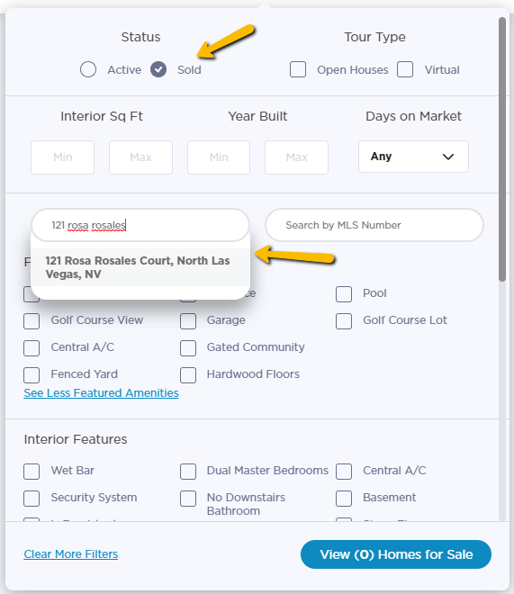
Multiple properties will pull up; click on View () Homes for Sale.
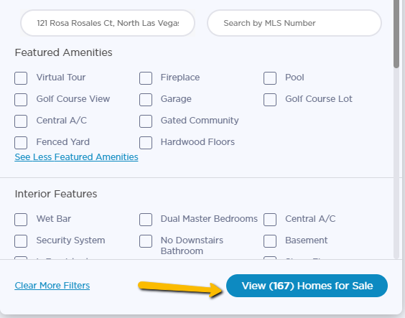
If the Sold property does not pop up right away, click on More Filters again, the address should still be populated; click on SOLD again, and click on View () Homes for Sale.
PAID FOR ADVERTISING: BOOSTING VS RUNNING ADS
***Pro Tip #1: You can only use these features if you have a business page. Paid advertising cannot be done on a personal page unless a PROFESSIONAL PROFILE, which you can switch to. I use Profile creator to post, and run ads off the business page with link to ylopo site, or profile creator you can boost, same results but have to re run once ends.
***Pro Tip #2: You're paid ads will run on FB, Instagram, and Audience Network (newsfeed, stories, messenger, marketplace)
Social Media Posting & Content Planning
THIS CHANGES ALL THE TIME - BEST IS MY JUNK VIDEO BEATS YOUR ABSENT ANY DAY!!
Frequency:

∙ Stories - Daily
∙ News Feed - 5-20 times a week
∙ Video - IG, Tik tok
What to Post:
∙ Stories: you should be “face forward,” engaging content (use stickers), tag people and location
∙ Newsfeed: Quality over quantity, education, and a long-form copy is best; tag people and location and hashtags
∙ Video: focus on reels if you can; knowledge and education are essential for reels on Instagram andTik Tok style. IGTV and Facebook Live are good, also.
∙ Repurpose content: blogs & newsfeed articles can also be used for video scripts and posts (think of IG & FB as your mini blog sites), and vice versa; video scripts can also be used as content for blogs and posts.
∙ Use content to create content. If you record a YouTube or IGTV or are going live – use that content to create posts and stories advertising your video.

How to Create an Adaptive Search for Ads

First, go to your branded search site xxxx.scofieldgroup.com

Next create a search, to the content wanted, for this I will use homes with large lots over ¼ acre, under $600k

Take that full URL and use it for your ads, use tinyurl.com if needed to shrink and customize the name.

